**ISPC 2018 BRISTOL CONFERENCE**

**The International Society for the Philosophy of Chemistry**

**Twenty-second annual conference**

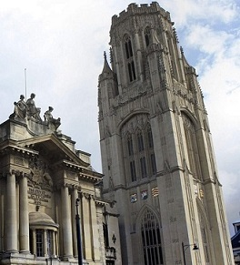

**16-18 July 2018**

**Venue: Lecture room LT3, Chemistry Building, Cantocks Close, Bristol, BS8 1TS**

**Plenary speakers**:

Elena Ghibaudi, University of Torino, Italy.

Robin Hendry, University of Durham, UK.

Jean-Pierre Llored, Linacre College, Oxford; Laboratoire Sphère, Université Paris 7.

Eric Scerri, University of California, Los Angeles, USA.

**Sponsors**:

British Society for the Philosophy of Science.

The Centre for Science and Philosophy.

Bristol Faculty of Arts Conference Support Fund.

**More conference details:**

<http://www.bristol.ac.uk/arts/events/2018/philosophy-of-chemistry-conference.html>;

**Conference registration:**

<https://shop.bris.ac.uk/conferences-and-events/faculty-of-arts/philosophy/ispc-22nd-annual-conference>

**Conference organiser**: [gb0859@bristol.ac.uk](mailto:gb0859@bristol.ac.uk);

**ISPC:** <https://sites.google.com/site/socphilchem/>