Cain Conference 2017: Chemistry in the Americas 1500-1800.

Beckman Center for the History of Chemistry

Chemical Heritage Foundation, Philadelphia, 28-29 April, 2017.

Conference Organizers: John R.R. Christie, Cain Conference Fellow 2017.

Carin Berkowitz, Director, Beckman Center for the

History of Chemistry, CHF Philadelphia.

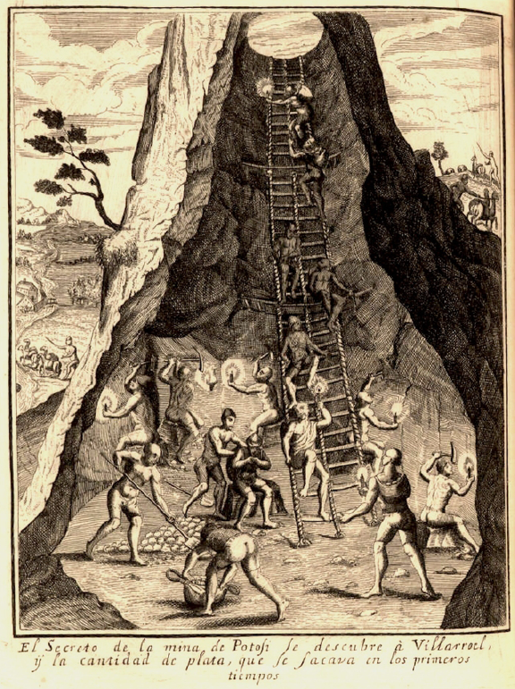
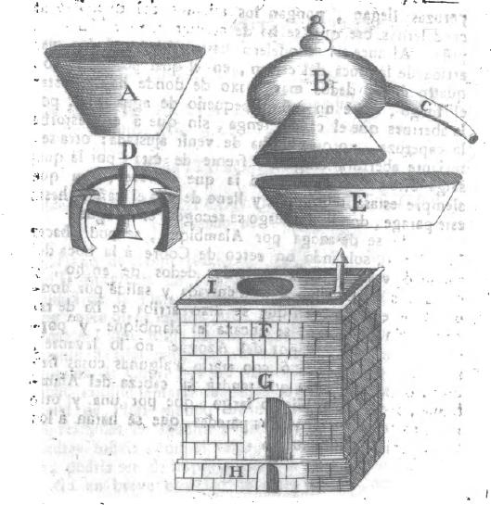
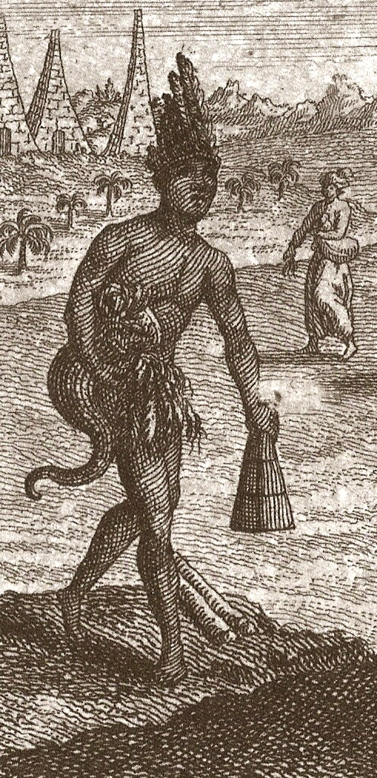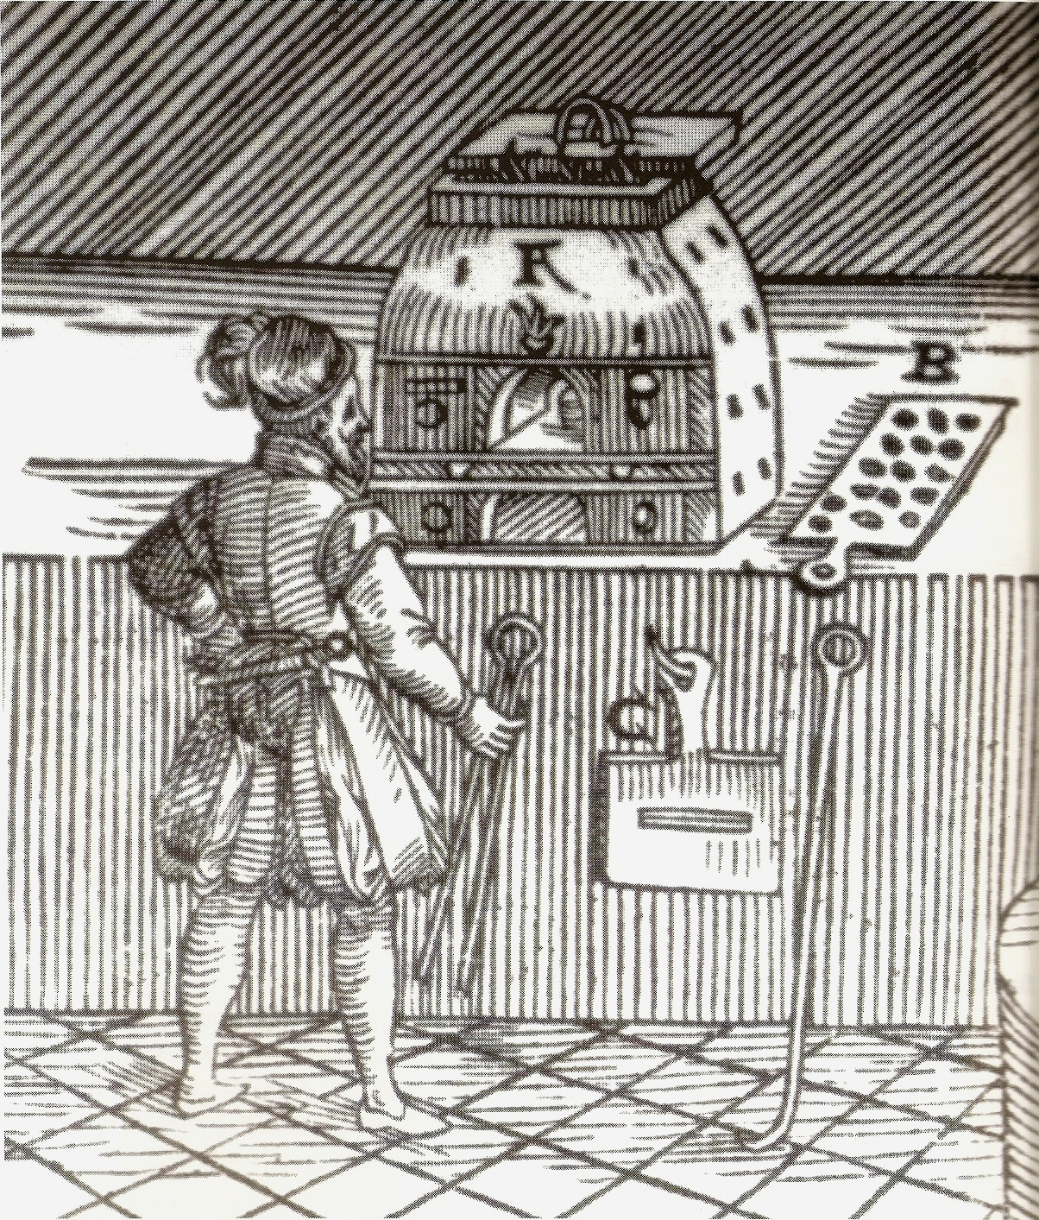

Provisional Programme.

Friday 28th. April.

9.30- 9.45 Welcome and Introduction. John Christie and Carin Berkowitz.

9.45-10.45 Brent Lane, Kenan Flagler Business School, University of North Carolina .

The Primacy of Chemistry Expertise in the Speculative Financing of
North American Settlement.

10.45 11.15 Coffee Break.

11.15-12-15. Samir Boumediene, ENS Lyon

A Specific Conquest: European Naturalists and the Search for
Specific Remedies in the Americas

12.15-13.15 Mariana Sanchez, Laboratoire ICT, University of Paris (Diderot).

Paracelsian Ideas in the treatise Arte de los Metales by Alvaro
Alonso Barba

13.15-14.15. Lunch.

14.15-16.15. Jennifer D. Miglus, Hartford Medical Society Historical Library
Donna Bilak, Columbia University

The Notebooks of Gershom Bulkely

16.15-16.45 Coffee/Tea Break.

16.45-17.15 Roundtable Discussion: The 17th. Century.

18.30 Reception+Conference Dinner.

Saturday 29th.April.

9:00-10:00 John Stewart, Oklahoma University

Scottish Chemistry and the Atlantic Enlightenment

10:00-11:00 Christopher Halm, Regensburg University

Early Agricultural Chemistry in the United States of America

11:00-12:00 Science History Walk.

12-13:00 Lunch.

13.00-14.00 Marc McDonald, University of Prince Edward Island

Failed Utopias and Practical Chemistry: the Priestleys, the Duponts and the
Transmission of Atlantic Science

14.00-15.00 Tom Apel, CHF

‘Nature is the Great Experimenter’: the Reception of Lavoisier’s Chemistry in America

15:00-15:30 Tea/Coffee Break.

15.30-16.00 Roundtable: Conclusions and Agendas.

